1.Create a comparison table listing at least 4 key features of RADIUS and TACACS+ side by side, highlighting which protocol supports each feature.
Feature | RADIUS | TACACS+
Authentication | Supports authentication | Supports authentication
Authorization | Limited authorization support | Full authorization support
Accounting | Supports accounting | Supports accounting
Transport Protocol | Uses UDP | Uses TCP
Encryption | Encrypts the user password | Encrypts the entire packet body
AAA Separation | Authentication and authorization are combined | Authentication, authorization and accounting are separated
Port Number | UDP 1812 for authentication and UDP 1813 for accounting | TCP 49
Common Usage | Used for network access, Wi-Fi and VPN authentication | Mainly used for network device administration

2.Draw a step-by-step flow diagram showing the RADIUS authentication process for a user logging in to a public WiFi hotspot, labeling each communication step between the client, network device, and RADIUS server.
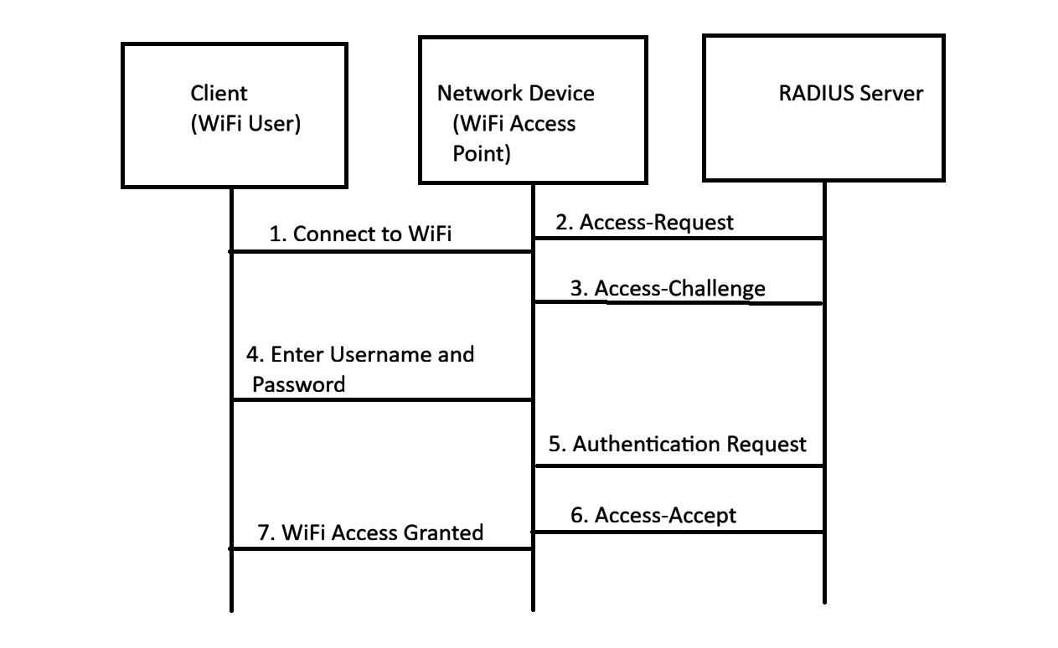
3.List 3 real-world use cases where TACACS+ is preferred over RADIUS, and briefly explain why TACACS+ is better suited for each scenario.
No. | Use Case | Why TACACS+ is Better Suited
1 | Network Device Administration | TACACS+ provides separate authentication and authorization, allowing administrators to have different levels of access to routers, switches and firewalls.
2 | Large Enterprise Networks | TACACS+ provides detailed control over administrator permissions and can record the commands executed by users on network devices.
3 | Network Operations and Security Teams | TACACS+ allows organizations to control which commands each administrator can execute. This helps prevent unauthorized configuration changes and improves accountability.
4.Given a scenario where a user tries to log into a network device but fails authentication, describe how RADIUS and TACACS+ would handle the logging and response differently.<br><br><em><strong>Hint:</strong> Focus on how each protocol manages accounting and command authorization.</em>
Point | RADIUS | TACACS+
Authentication Failure | RADIUS server rejects the login request and sends an Access-Reject response. | TACACS+ server rejects the authentication request and sends a failure response.
Logging | RADIUS can record authentication and accounting information, such as login sessions. | TACACS+ provides detailed logging of administrator authentication and activities.
Accounting | RADIUS mainly records session information such as start, stop and duration. | TACACS+ can provide detailed accounting of administrator activities and commands.
Command Authorization | RADIUS has limited support for controlling individual commands. | TACACS+ can authorize individual commands, allowing or denying specific commands.

5.Use ChatGPT or another AI tool to generate a sample RADIUS configuration snippet for a Cisco router, then review the output and list any changes you would make to adapt it for a college campus WiFi setup.
